**The SCO vs. NATO: The Clash of Two Security Paradigms**

[](https://substack.com/profile/5695118-matthew-ehret)

[MATTHEW EHRET](https://substack.com/@matthewehret)

MAY 13, 2024

from: Matthew Ehret <matthewehret@substack.com>

reply-to: Matthew Ehret <reply+2e15hy&doii8&&fb0dd183602845bb9265aea1f81edf9bef7a957ff1525999144ebca280f0cccf@mg1.substack.com>

to: fchase@gmail.com

date: May 13, 2024, 8:12 AM

subject: The SCO vs. NATO: The Clash of Two Security Paradigms

mailed-by: mg1.substack.com

[[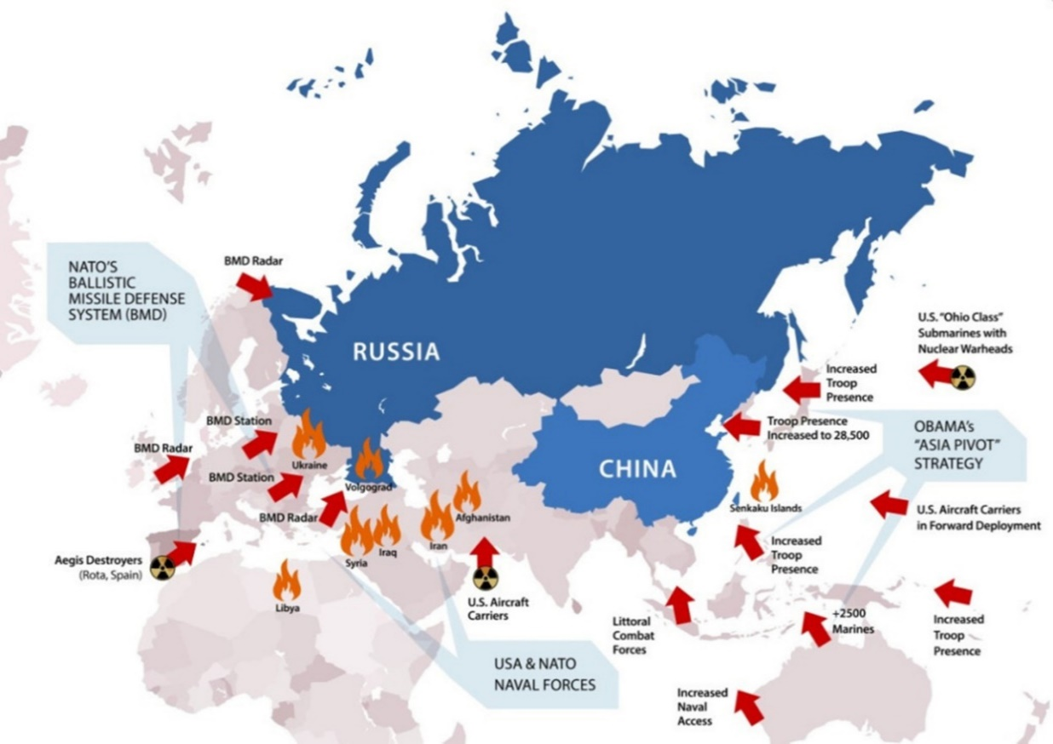](https://substackcdn.com/image/fetch/f_auto,q_auto:good,fl_progressive:steep/https:/substack-post-media.s3.amazonaws.com/public/images/506a1690-49b1-4bb8-873a-fc469f74fab6_1253x886.jpeg)](https://substackcdn.com/image/fetch/f_auto,q_auto:good,fl_progressive:steep/https%3A%2F%2Fsubstack-post-media.s3.amazonaws.com%2Fpublic%2Fimages%2F506a1690-49b1-4bb8-873a-fc469f74fab6_1253x886.jpeg" \t "_blank)

In a perverse replay of the build up to the first World War, the British are once again up to their dirty tricks and desperate to kick over the global chess board using the time-tested trick of “mutual security pacts”.

Powder kegs that could devolve into a chain reaction breakdown of global war have been set across the globe, from the Ukraine and expanded NATO on Russia’s southwestern frontier, to the tinder box of the Pacific with expanded “NATO” encircling China.

Just this week, it has been made known that Japan is on the fast [track for joining the AUKUS alliance](https://www.australiandefence.com.au/news/news/japan-cleared-to-join-aukus-alliance) (Australia, UK, USA), with New Zealand, South Korea and the Philippines not far behind.

Additionally, the stage has been set for Taiwan to be the [“Ukraine of the Pacific”](https://cynthiachung.substack.com/p/the-real-global-agenda-pushing-for?utm_source=publication-search), [with Green Berets now training Taiwanese forces](https://asiatimes.com/2024/03/us-green-berets-deploying-to-taiwans-front-line/), and billions of dollars of US supplied weapons, equipment and battle plans expanding over the last 12 months in preparation for an upcoming war with mainland China.

On the Arctic front, Canada’s puppet regime of Justin Trudeau [has announced a new military doctrine](https://www.nnsl.com/news/arctic-sovereignty-anchors-federal-plans-to-upgrade-canadas-military-7342494) premised around a war-posture with Russia while reviving a ballistic missile shield agenda, extending NATO’s “full spectrum dominance” strategy into the arctic frontier. As this policy was announced, Canada additionally [made its intentions of joining the AUKUS alliance known.](https://www.eurasiantimes.com/aukus-expansion-may-be-on-the-cards-as-canada/)

Perhaps the most delicate tinderbox underpinning this global network of war is the Israel card, where an end times cult of Zionist fanatics committed [to rebuilding Solomon’s Temple](https://thepeoplesvoice.tv/israel-building-altar-for-red-heifer-sacrifice-to-fulfill-biblical-end-times-prophecy/) have been activated with a mandate to **purge a vast territory** [dubbed ‘Greater Israel’](https://www.thelastamericanvagabond.com/greater-israel-power-armageddon/) **of the Arabs who have been living there for millennia**.

[[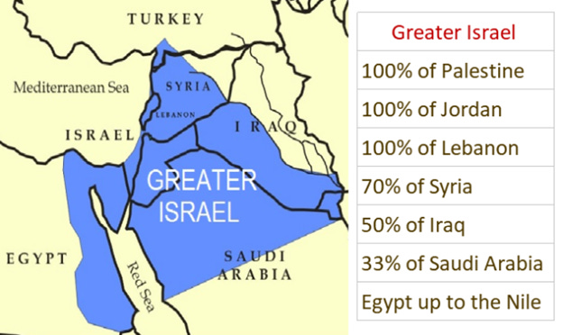](https://substackcdn.com/image/fetch/f_auto,q_auto:good,fl_progressive:steep/https:/substack-post-media.s3.amazonaws.com/public/images/adfaf498-8b2e-43a0-9f29-ee4e7df0d1e7_624x372.png)](https://substackcdn.com/image/fetch/f_auto,q_auto:good,fl_progressive:steep/https%3A%2F%2Fsubstack-post-media.s3.amazonaws.com%2Fpublic%2Fimages%2Fadfaf498-8b2e-43a0-9f29-ee4e7df0d1e7_624x372.png" \t "_blank)

The key to the secret sauce of forever wars during the past two hundred years has been binding military pacts that promote “collective security” of all members in any conflict.

This is what makes [Article 5 of NATO](https://www.foxnews.com/world/russian-invasion-what-nato-article-5-treaty) so dangerous, as it enforces a legally binding mandate onto all NATO members into supporting a war if any particular member gets into a conflict regardless of the justice of said conflict.

NATO’s collective security pact is actually a rehashing of the earlier failed attempt at a one world military force imposed onto sovereign nations [under Articles 10 and 16 of the League of Nations 1919 Covenant](https://avalon.law.yale.edu/20th_century/leagcov.asp)[[1]](https://badlands.substack.com/p/the-sco-vs-nato#_ftn1), which was rejected by the organizational efforts of patriots in America that had grouped themselves around President Warren Harding.

When the United Nations’ Security Council gave too much power to nations on the wrong side of Churchill’s Iron Curtin to veto military decisions of the Anglo-American oligarchs during the early days of the Cold War, the decision to create an alternative military organization far removed from the UN was brought online, led by Great Britain. The purpose of this organization, as outlined by Lord Halifax was ‘to keep the Germans down, the Russians out and America in”.

With the North Atlantic Treaty Organization in place by April 8, 1949, the worst elements of the League of Nations Covenant was revived, and a new supranational structure was created, which interfaced with the newly established Five Eyes and CIA (created in 1946 and 1947 respectively).

Under the guiding hand of Allan Dulles, NATO soon found itself under the management of leading unreconstructed Nazis, French Vichy, and Italian fascists running what soon came to be known as ‘NATO’s secret armies’. **This would become a globally-extended parallel state** managing global terrorism, assassination bureaus (like Permindex), organized crime syndicates and much more.

**The Nazis that Ran NATO**

In fact, between 1950 until the 1980s, NATO had multiple unreconstructed Nazis in control of multiple departments, including several consecutive Commanders of central Europe!

**Adolf Heusinger, Chief of the General Staff for the Nazis**

Post WWII: Chief of the West German army, general of the Bundeswehr from 1957 to 1961, and also Chairman of the NATO Military Committee from 1961-1964.

[[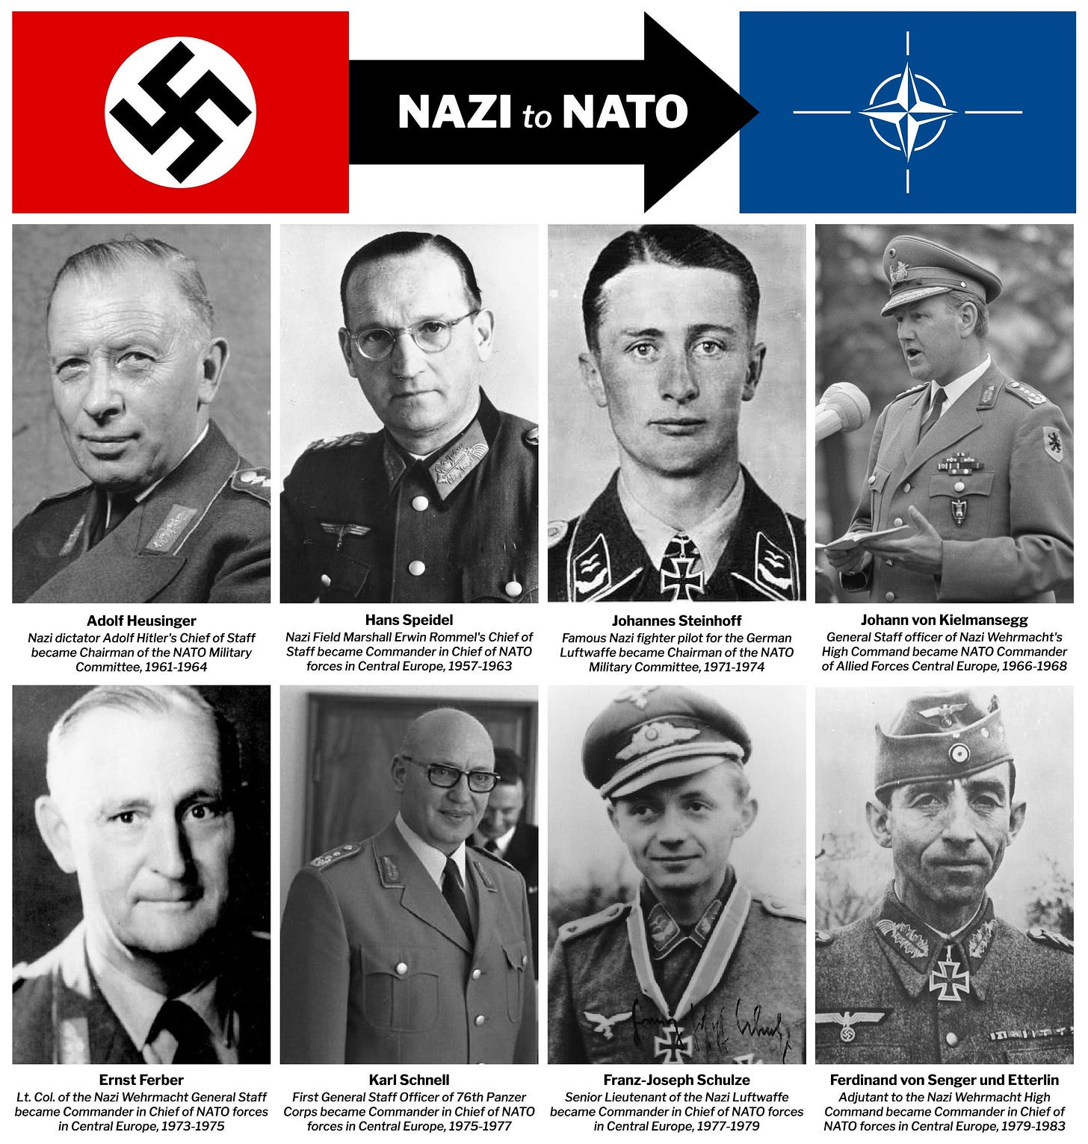](https://substackcdn.com/image/fetch/f_auto,q_auto:good,fl_progressive:steep/https:/substack-post-media.s3.amazonaws.com/public/images/3ec00426-ed84-4e6a-bdd6-76ef35f0fc62_2158x2270.jpeg)](https://substackcdn.com/image/fetch/f_auto,q_auto:good,fl_progressive:steep/https%3A%2F%2Fsubstack-post-media.s3.amazonaws.com%2Fpublic%2Fimages%2F3ec00426-ed84-4e6a-bdd6-76ef35f0fc62_2158x2270.jpeg" \t "_blank)

**Hans Speidel, a Nazi general during WWII**

Post WWII: Founder of the Bundeswehr who oversaw the Bundeswehr’s integration into NATO.

From 1957-1963, became Supreme Commander of NATO’s ground force in Central Europe

**Johannes Steinhoff**

During WWII: Luftwaffe fighter and recipient of the Knight’s Cross of the Iron Cross (the Nazi military’s highest award).

Post WWII: Served as Acting Commander of Allied Air Forces Central Europe in NATO from 1965-1966, as Inspector of the Air Force 1966-1970 and as Chairman of the NATO Military Committee from 1971–1974.

**Johann von Kielmansegg**

During WWII: General Staff officer to the High Command of the Wehrmacht 1942-1944.

Post WWII: Lieutenant general of NATO’s Supreme Command of Allied Land Forces Central Europe in Fontainebleau, and NATO’s Commander in Chief of Allied Forces Central Europe from 1967-1968.

**Jurgen Bennecke**

During WWII: General in the Wehrmacht.

Post WWII: NATO’s Commander in Chief of the Allied Forces Central Europe from 1968-1973.

**Ernst Ferber**

During WWII: Major in the Wehrmacht, and group leader of the organizational department of the Supreme Command of the Army (Wehrmacht) from 1943-1945.

Post WWII: NATO’s Commander in Chief of Allied Forces Central Europe from 1973-1975.

**Karl Schnell**

During WWII: First General Staff Officer of the LXXVI Panzer Corps in 1944, and recipient of the Iron Cross 2nd Class.

Post WWII: NATO’s Commander in Chief of Allied Forces Central Europe from 1975-1977.

**Franz Joseph Schulze**

During WWII: Chief of the 3rd Battery of the Flak Storm Regiment 241 and recipient of the Knight’s Cross of the Iron Cross.

Post WWII: NATO’s Commander in Chief of Allied Forces Central Europe from 1977-1979.

**Ferdinand von Senger und Etterlin**

During WWII: Lieutenant of 24th Panzer Division in the German 6th Army, adjutant to Army High Command.

Post WWII: NATO’s Commander in Chief of Allied Forces Central Europe 1979-1983.

And Many more…

In fact, the position of NATO Commander and Chief of Allied Forces Central Europe was a position that was filled SOLELY by ‘former’ Nazis for 16 YEARS STRAIGHT, from 1967-1983.

[[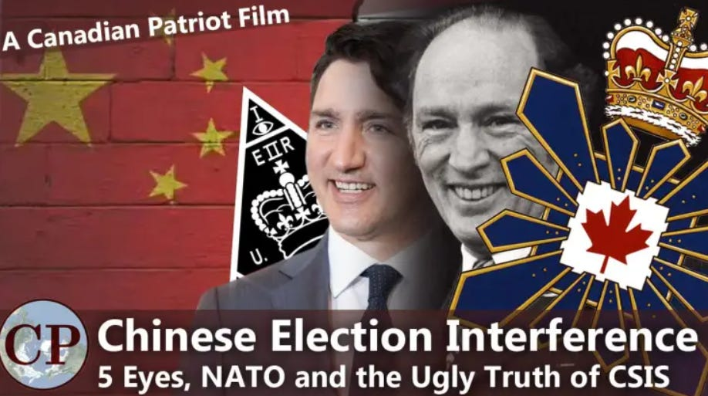](https://canadianpatriot.org/2023/07/16/chinese-election-interference-five-eyes-nato-and-the-ugly-truth-of-csis-a-canadian-patriot-film/)](https://canadianpatriot.org/2023/07/16/chinese-election-interference-five-eyes-nato-and-the-ugly-truth-of-csis-a-canadian-patriot-film/" \t "_blank)

Even Hitler’s Intelligence Chief Reinard Gehlen found new employment under the CIA’s Allan Dulles as the head of western German intelligence from 1956-1968.

Among those WW2 killers who worked with Gehlen in Europe was Stefan Bandera, the vicious Ukrainian fascist, and thousands of members of the Organization of Ukrainian Nationalists whose skills were put to work carrying out asymmetric warfare against socialist-leaning leaders of Europe—and also the population more generally.

In [The Empire on Which the Black Sun Never Set](https://cynthiachung.substack.com/p/my-first-book-is-now-outthe-empire), historian Cynthia Chung noted that a vast ‘secret fascist army of Nazi, and Italian fascist stay-behinds was organized under NATO’. These ‘stay behinds were used to carry out assassinations of anti-imperial leaders like Italy’s former Prime Minister Aldo Moro in 1978, Sweden’s Prime Minister Olof Palme in 1986 (known as Sweden’s JFK), Italian industrialist Enrico Mattei in 1960, Turkey’s Prime Minister Adnan Menderes in 1961 along with two cabinet colleagues, and U.S. President Kennedy in 1963, and multiple attempts against French President Charles de Gaulle.

Chung writes that, on top of targeting assassinations, NATO’s secret armies*“were to be used against the people. The desire was that by staging false-flag operations that were blamed on communists, panic and revulsion would be invoked sending voters flocking to the welcoming arms to so-called ‘secure’ right-wing governments.”*

**A Different Paradigm of Mutual Security: The SCO and CSTO**

During the Cold War, NATO’s counterpart on the other side of the Iron Curtin was called ‘The Warsaw Pact,’ established in 1955, and whose members included the Soviet Union, Albania, Bulgaria, Czechoslovakia, East Germany, Hungary, Poland and Romania.

[[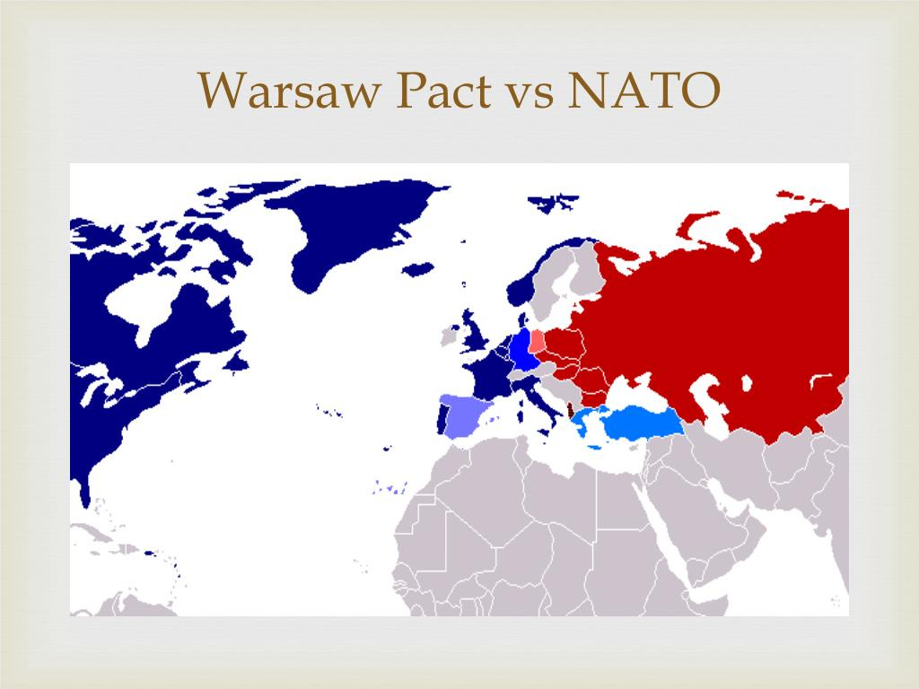](https://substackcdn.com/image/fetch/f_auto,q_auto:good,fl_progressive:steep/https:/substack-post-media.s3.amazonaws.com/public/images/e4eb07f9-e571-4964-8e6a-220306b82e67_1024x768.jpeg)](https://substackcdn.com/image/fetch/f_auto,q_auto:good,fl_progressive:steep/https%3A%2F%2Fsubstack-post-media.s3.amazonaws.com%2Fpublic%2Fimages%2Fe4eb07f9-e571-4964-8e6a-220306b82e67_1024x768.jpeg" \t "_blank)

Despite neither side’s hands being clean during the dark days of the Cold War, any sober comparison of acts of organized terror, assassinations of heads of state, overthrows of governments, and intentional subversions of the desires of poor nations to industrialize, the Nazi-run NATO apparatus representing “freedom and democracy” bears a FAR greater burden of the sin carried out during that existential period of human history.

Since 2001, two Eurasian-led organizations have been created and which serve as counterparts to NATO, dubbed

* the Shanghai Cooperation Agreement (SCO,) and
* the Collective Security Treaty Organization (CSTO).

While the SCO does not have a collective defense pact obliging members to engage in hostilities under conditions of a war, bilateral treaties among the SCO members on defense and mutual security would be difficult to by-pass under the conditions of the launching of a hot war.

The CSTO, created in 2002, does have a collective security pact in its Article 4; however, due to the general weakness of the members (only Russia wields a significant military force), and due to the nearly insignificant activity either in active peace keeping missions or annual exercises, which pale when compared to the scope of NATO, the CSTO isn’t seen as strategic of a factor on the playing field of ‘the great game’.

Besides Russia, its other members include: Armenia, Belarus, Kazakhstan, Kyrgyzstan, Russia, and Tajikistan.

[[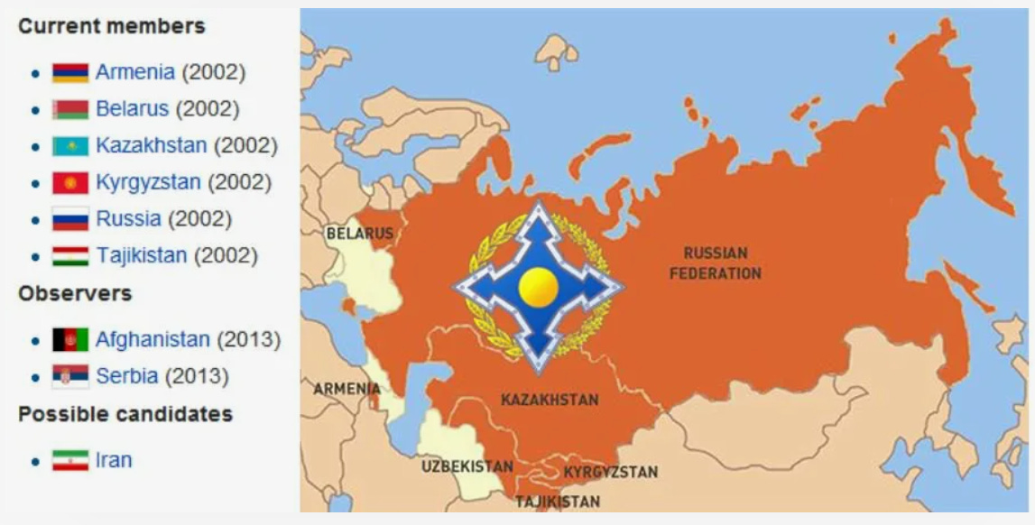](https://substackcdn.com/image/fetch/f_auto,q_auto:good,fl_progressive:steep/https:/substack-post-media.s3.amazonaws.com/public/images/a3f84a24-ae00-4132-8d2f-42dec252ae7a_1147x582.png)](https://substackcdn.com/image/fetch/f_auto,q_auto:good,fl_progressive:steep/https%3A%2F%2Fsubstack-post-media.s3.amazonaws.com%2Fpublic%2Fimages%2Fa3f84a24-ae00-4132-8d2f-42dec252ae7a_1147x582.png" \t "_blank)

Much more relevant than the CSTO, and not well understood by many westerners, is **the Shanghai Cooperation Organization (SCO,)** founded in 2001 and whose membership includes: Russia, China, Iran, Pakistan, India, Kazakhstan, Kyrgyzstan, Russia and Tajikistan.

The actual birth of the SCO must be found in then-Russian Defense Minister Primakov’s brilliant insight to bring Russia into an alliance with a Chinese-led security compact set up in 1996 dubbed [‘The Shanghai Five’](https://www.brookings.edu/articles/shanghai-five-an-attempt-to-counter-u-s-influence-in-asia/) (China, Kazakhstan, Kyrgyzstan, Russia, and Tajikistan,) which was set up to secure China’s borders in an attempt to reduce the chaos of a new age of radical Islamist chaos and war, which anyone reading Zbigniew Brzezinski’s writings could clearly see was going to define the Eurasian continent in a vast balkanization and asymmetrical warfare strategy led by NATO.

As of this moment, an additional 14 nations are dialogue partners, including Saudi Arabia, UAE, Egypt, Turkey, Mongolia, Sri Lanka, and [10 nations have submitted formal requests](https://www.riotimesonline.com/brazil-news/modern-day-censorship/the-shanghai-cooperation-organization-is-inundated-with-requests-for-membership-incl-from-saudia-arabia-and-uae/) to join as full SCO members, which represent 80% of the land area of Eurasia and 40% of the world population, and over 33% of world GDP.

[[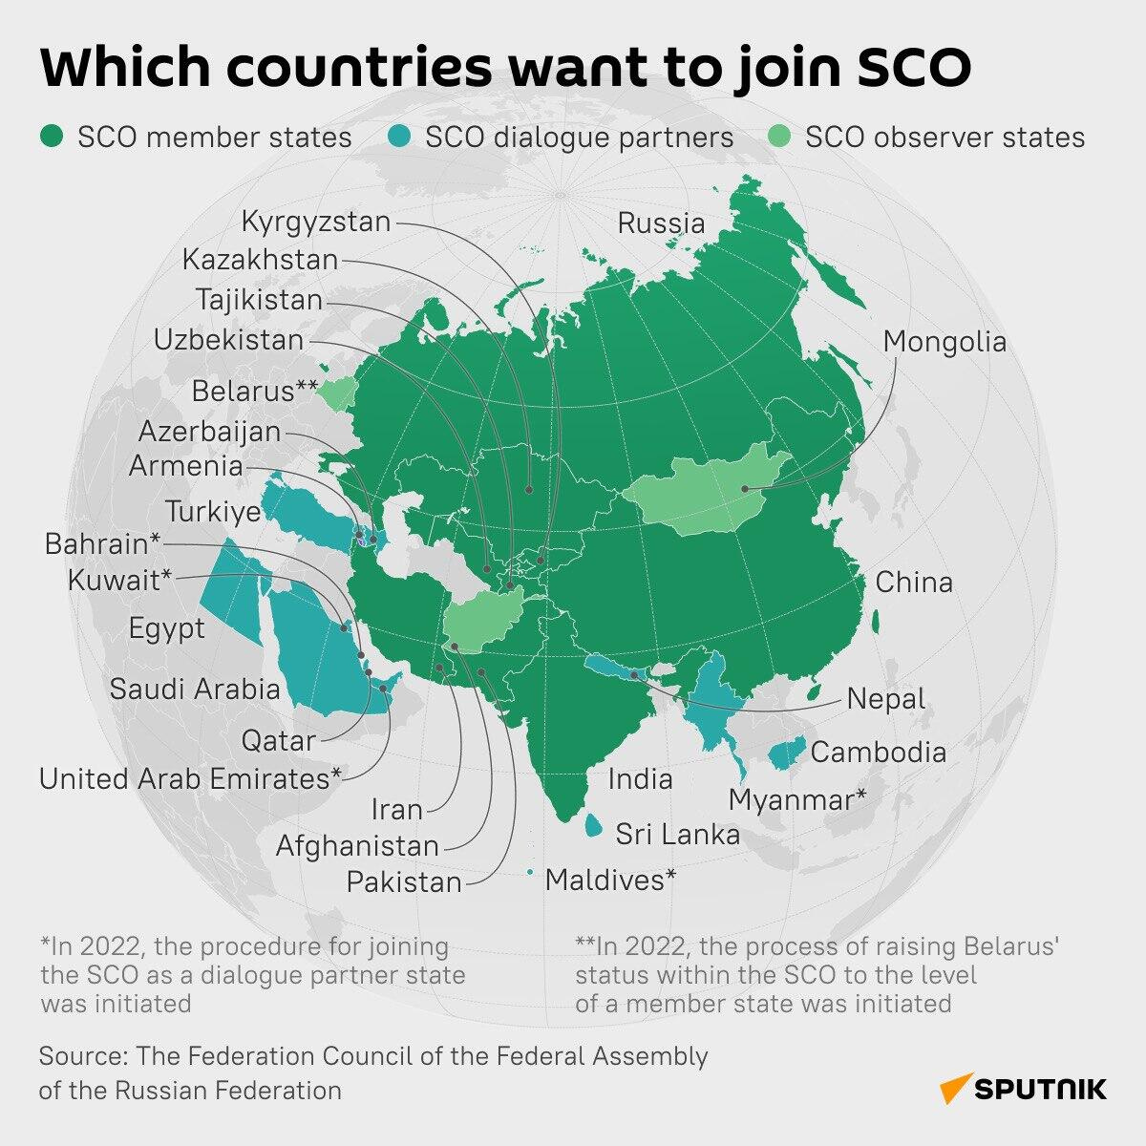](https://substackcdn.com/image/fetch/f_auto,q_auto:good,fl_progressive:steep/https:/substack-post-media.s3.amazonaws.com/public/images/773d6cd2-2f3d-40d2-b83d-8e61c3f93f5a_1200x1200.jpeg)](https://substackcdn.com/image/fetch/f_auto,q_auto:good,fl_progressive:steep/https%3A%2F%2Fsubstack-post-media.s3.amazonaws.com%2Fpublic%2Fimages%2F773d6cd2-2f3d-40d2-b83d-8e61c3f93f5a_1200x1200.jpeg" \t "_blank)

As mentioned earlier, the SCO was the brainchild of Russian grand strategist Yevgeny Primakov, who served as Director of Russia’s Foreign Intelligence Service from 1991-1996, Foreign Minister from 1996-1998 and Prime Minister from 1998-1999.

It was Primakov who spearheaded [a new Eurasian security and cooperation doctrine](https://fitzinfo.net/2021/07/14/russia-china-issued-joint-declaration-for-multi-polar-world-and-the-formation-of-a-new-international-order-in-1997/) centered around the concept of multipolarity based on a combined Russian-Chinese-Iranian core alliance, and it was Primakov who sponsored a then-little known trouble shooter named Vladimir Putin to replace the drunken train-wreck Boris Yeltsin on Christmas Day 1999.

[[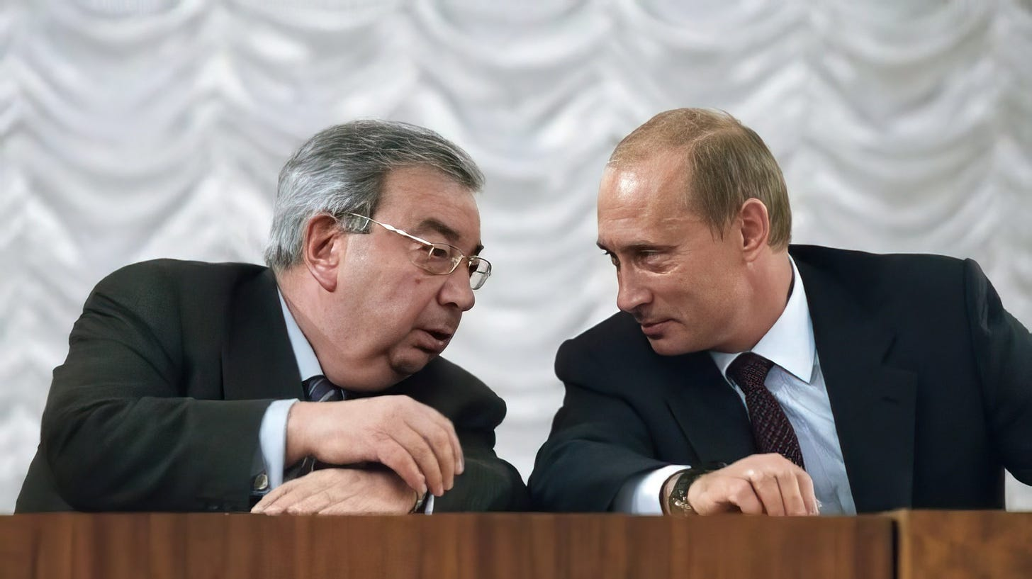](https://substackcdn.com/image/fetch/f_auto,q_auto:good,fl_progressive:steep/https:/substack-post-media.s3.amazonaws.com/public/images/116b8590-3750-4360-8c08-059ca67ddd3a_1920x1078.jpeg)](https://substackcdn.com/image/fetch/f_auto,q_auto:good,fl_progressive:steep/https%3A%2F%2Fsubstack-post-media.s3.amazonaws.com%2Fpublic%2Fimages%2F116b8590-3750-4360-8c08-059ca67ddd3a_1920x1078.jpeg" \t "_blank)

After returning from a Moscow summit in 1997, Russian security concerns over the danger of NATO expansion were expressed to then-Senator Joe Biden (member of the Senate Foreign Relations Committee), who expressed his incredulity about the Russian threat to work more closely with China.

In a 1997 statement that did not age well at all, Biden said:

[Biden](https://www.youtube.com/watch?v=YXaUCKV-jBk)

In response to

* Biden’s belligerence and
* the clear intent to expand NATO indefinitely around both Russia and China,

a meeting was arranged between Russian and Chinese leaders, and the SCO’s official birth was announced with the first Russian-Chinese Joint Declaration on a Multipolar World[[2]](https://badlands.substack.com/p/the-sco-vs-nato#_ftn2), calling explicitly for a rejection of [unipolarism and the embrace of a different strategy premised on multipolarism.](https://archive.org/details/RussianChineseJointDeclarationOnMultipolarWorldEstblOfANewIntlOrder19977pgsPOL.sml)

**Winning isn’t just about Military Might**

In opposition to the framework of the North Atlantic Treaty Organization, the SCO is not limited to military considerations, but involves a much wider mandate, including economic, energy, transport, cultural and industrial activities, which makes its operating philosophy intrinsically superior to the western myopic fixation with “power politics” and projection of influence onto subordinates.

[As outlined on Zero Hedge in November 2023,](https://www.zerohedge.com/geopolitical/visualizing-expansion-shanghai-cooperation-organization) “The [SCO] organization has undertaken over 20 large-scale projects related to transportation, energy, and telecommunications. A notable initiative is China’s expansive Belt and Road Initiative (BRI), which aims to rebuild the Silk Road and connect China to Asia, Europe, and beyond through significant infrastructure investments.”

[[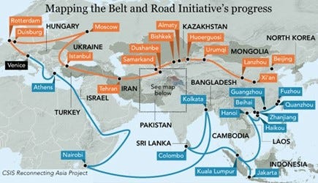](https://substackcdn.com/image/fetch/f_auto,q_auto:good,fl_progressive:steep/https:/substack-post-media.s3.amazonaws.com/public/images/68408376-34a0-4d19-aea1-ae22cf0baf81_435x250.jpeg)](https://substackcdn.com/image/fetch/f_auto,q_auto:good,fl_progressive:steep/https%3A%2F%2Fsubstack-post-media.s3.amazonaws.com%2Fpublic%2Fimages%2F68408376-34a0-4d19-aea1-ae22cf0baf81_435x250.jpeg" \t "_blank)

Pakistan and much of Southwest Asia are also increasingly on board the BRI through the growing [China-Pakistan Economic Corridor](http://cpec.gov.pk/). [Twenty Arab states have signed onto the BRI](https://risingtidefoundation.substack.com/p/favorable-winds-from-china-how-the), and much of [Latin America](https://risingtidefoundation.net/2021/09/08/new-silk-road-prepares-new-paradigm-in-latin-america/) has also joined with hundreds of billions of dollars of infrastructure projects.

Complementing the SCO and BRI is another multipolar organization created in 2008 called the Eurasian Economic Union, which is now in the final stages of a long-planned economic treaty between China and the Russian-led economic block[recently outlined by Putin advisor Sergey Glazyev (head of Macroeconomic Integration of the Eurasian Economic Union).](http://www.eurasiancommission.org/en/nae/news/Pages/17-09-2020-1.aspx)

**The Strategic Importance of the International North-South Transportation Corridor**

One of the keystone projects driving this program involves the completion of the International North-South Transportation Corridor (INSTC), launched as an Indian-Iranian-Russian program in 2002, and which has been given new life in the last several years.

[[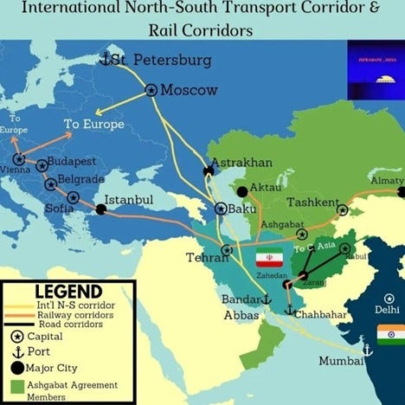](https://substackcdn.com/image/fetch/f_auto,q_auto:good,fl_progressive:steep/https:/substack-post-media.s3.amazonaws.com/public/images/2dffcdec-fedc-4800-984d-1385164757eb_468x468.jpeg)](https://substackcdn.com/image/fetch/f_auto,q_auto:good,fl_progressive:steep/https%3A%2F%2Fsubstack-post-media.s3.amazonaws.com%2Fpublic%2Fimages%2F2dffcdec-fedc-4800-984d-1385164757eb_468x468.jpeg" \t "_blank)

While the west has not built any new cities in several generations, Russia has announced the construction of five major Arctic cities supporting up to 1 million people each in the coming years, with Russian Defense Minister Sergey Shoigu leading the plan.

Reporting on this program, Atle Staalesen [wrote in Arctic Today](https://www.arctictoday.com/what-a-new-russian-grand-masterplan-for-siberia-could-mean-for-the-arctic/):

*“Shoigu sees his masterplan for Siberia as closely connected with the markets in nearby China. But the new cities will also be important for the development of the Arctic, he argues, and makes a reference to the famous 18th Century scientist and writer Mikhail Lomonosov, who wrote that “Russian power will grow with Siberia and the Arctic Ocean, […]”.*

*According to Shoigu, Lomonosov did not coincidently connect the Arctic and Siberia. “They should be developed together and not separately,” he underlines, and adds that “the focus on the development of the Siberian region is both timely and reasonable.”*

Typically framed as an “anti-BRI” mega project by small-minded geopoliticians, the INSTC and BRI are really two sides of the same program, and should much rather be seen as a sister program for Eurasian, Southwest Asian and even African industrial growth.

The INSTC currently enjoys the cooperation of 12 participating nations, and has recently seen its northern extension moved from St Petersburg further north to the port of Lavna in Murmansk, Russia. China’s western “middle corridor” branch of the east-west BRI stretching through Xinjiang also features several rail and road corridors that tie directly into the INSTC, not to mention the obvious Arctic far east connections.

When fully completed, the INSTC will not only circumvent the NATO-controlled zone of the mediterranean zone via the overly-congested Suez canal, but will cut approximately 10 days and 40% of the transportation costs off the current Suez route.

[[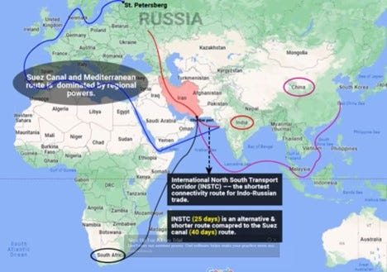](https://substackcdn.com/image/fetch/f_auto,q_auto:good,fl_progressive:steep/https:/substack-post-media.s3.amazonaws.com/public/images/eb8338db-d32b-4c4c-97d4-49d3ac8c29ff_468x329.jpeg)](https://substackcdn.com/image/fetch/f_auto,q_auto:good,fl_progressive:steep/https%3A%2F%2Fsubstack-post-media.s3.amazonaws.com%2Fpublic%2Fimages%2Feb8338db-d32b-4c4c-97d4-49d3ac8c29ff_468x329.jpeg" \t "_blank)

In 2019, China and Russia signed the first [scientific cooperation agreement](http://tass.com/press-releases/1053930) together, setting up the *“China-Russia Arctic Research Center”* as a part of the Polar Silk Road.

[[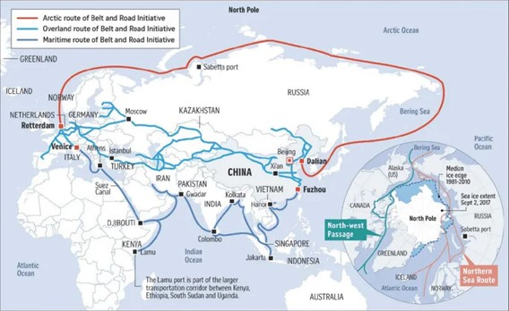](https://substackcdn.com/image/fetch/f_auto,q_auto:good,fl_progressive:steep/https:/substack-post-media.s3.amazonaws.com/public/images/21480eae-6421-4e3b-b30f-97dc54dcfb71_568x348.jpeg)](https://substackcdn.com/image/fetch/f_auto,q_auto:good,fl_progressive:steep/https%3A%2F%2Fsubstack-post-media.s3.amazonaws.com%2Fpublic%2Fimages%2F21480eae-6421-4e3b-b30f-97dc54dcfb71_568x348.jpeg" \t "_blank)

**Winning War isn’t About Projecting Military Power Alone**

Any competent military strategy must be premised not on destroying enemies, as the western Hobbesian military think tank complex of NATO has premised its Game Theory assumptions, but rather on peace. This means finding the most effective means of ending conflict and securing durable peace, two notions which NATO strategists have no conception of.

Anyone seriously intending to end conflicts, and secure durable peace, must prioritize the means of production (not only of military but also of civilian, and infrastructure-related products), as well as an outlook towards creating economic opportunities and trust building based on tangible large scale, long term projects that will improve conditions of life of neighboring people, improve educational and job opportunities for youth, improve national sovereign power of participating nations as a whole and increase a sense of freedom and security for citizens.

Thinking on those terms might be considered “utopian” or “out of touch with reality” by cynical folks today who have only known life under the conditions of empire and globalization; however, in saner times long past, this outlook was not only more normalized among westerners, but was the life blood that made the United States of America viable and good.

**Remembering the USA’s Better Foreign Policy Outlook**

Vice President Henry Wallace laid out this powerful American paradigm brilliantly in his 1942 speech to the American people in which he laid out his understanding that the American Revolution’s mission of 1776 was integrally tied into the liberation of all people of the world from institutions of empire:

Wallace also warned of the danger of US fascism and war with Russia (before being fired from his position as Vice-President):

*“Fascism in the postwar inevitably will push steadily for Anglo-Saxon imperialism and eventually for war with Russia. Already American fascists are talking and writing about this conflict and using it as an excuse for their internal hatreds and intolerances toward certain races, creeds and classes.”*

Brilliantly showcasing this better US tradition, a young Senator John F. Kennedy expressed his sensitivity to the plight of the Arab world and problem of Anglo-American imperialism when he said,

*“Our intervention in behalf of England’s oil investments in Iran, directed more at the preservation of interests outside Iran than at Iran’s own development…. Our failure to deal effectively after three years with the terrible human tragedy of the more than 700,000 Arab refugees [Palestinians], these are things that have failed to sit well with Arab desires and make empty the promises of the Voice of America….”*

Later, speaking in a 1960 speech regarding ending colonialism in Africa, JFK expressed his understanding of Africa’s demand for genuine independence, saying,

*“Call it nationalism, call it anti-colonialism, Africa is going through a revolution…. Africans want a higher standard of living. Seventy-five percent of the population now lives by subsistence agriculture. They want an opportunity to manage and benefit directly from the resources in, on, and under their land…. The African peoples believe that the science, technology, and education available in the modern world can overcome their struggle for existence, that their poverty, squalor, ignorance, and disease can be conquered…. [The] balance of power is shifting … into the hands of the two-thirds of the world’s people who want to share what the one-third has already taken for granted….”*

Kennedy wasn’t only using nice words, but put his every effort into providing US assistance to the industrial development aspirations of nations around the world, showcased brilliantly in his efforts [to assist President Kwame Nkrumah of Ghana to build the largest hydro-electric dam in Africa](https://larouchepub.com/other/2013/4035jfk_v_empire.html), called the Volta river Dam.

Projects like the Peace Corps and efforts to expand industrial growth in South America in such a manner that it would benefit the people and not simply western cartels were also extremely normal expressions of the better US foreign policy to poor people prior to the 1970s.

[[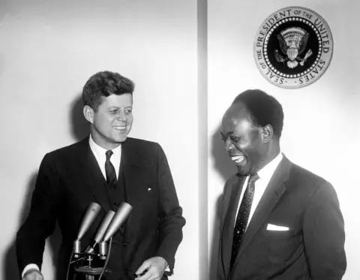](https://substackcdn.com/image/fetch/f_auto,q_auto:good,fl_progressive:steep/https:/substack-post-media.s3.amazonaws.com/public/images/b9768eae-8e31-49da-a048-79e4f08aa104_480x373.webp)](https://substackcdn.com/image/fetch/f_auto,q_auto:good,fl_progressive:steep/https%3A%2F%2Fsubstack-post-media.s3.amazonaws.com%2Fpublic%2Fimages%2Fb9768eae-8e31-49da-a048-79e4f08aa104_480x373.webp" \t "_blank)

**The Malthusian Takeover of America**

Sadly, with the usurpation of US military policy-making by death cultists affiliated with David Rockefeller’s Trilateral Commission in the early 1970s, US priorities towards colonialized peoples found itself driven by [Henry Kissinger’s NSSM-200](https://www.population-security.org/11-CH3.html), which moved US foreign policy aims away from actual development of “third-world nations” towards new priorities driven by an obsession with depopulation and resource control.

Plans advocating nuclear power, hydro-electric dams, industrial growth in general as promoted by the likes of John F. Kennedy and his martyred brother were scrapped in favor of US/World Bank loans permitted only for “appropriate technologies” laced with vicious usurious conditionalities that ensured foreign corporations would forever control extractive resources and mines in target nations, while “appropriate technologies” would be defined as zero-technological growth forms of windmills, solar panels and biodiesel development.

Within this hegemonic structure, private corporate and banking power structures as rigged by the Bilderberg Group (and junior Bilderberg Group dubbed ‘World Economic Forum) would become more powerful than nation states, and power of the United States became one of enforcing through military, and economic warfare the will of an unelected high priest class of feudalists above the nations of the world.

Regime change wars, divide to conquer programs, color revolutions and speculative attacks (a la Soros) onto nations unwilling to sacrifice their people onto the altar of globalization became the dominant forces of chaos for the next decades, and it is only now, with the true blossoming of the multipolar alliance that a configuration of nation states has been brought online which can conduct the sort of effective battle with this oligarchical cancer, which individually could not occur if any single member of the SCO or BRICS+ attempted to fight alone.

So today, Joe Biden’s 1997 condescending dare to his Russian counterparts to create a Russia-China-Iran alliance has come back to bite with a vengeance.

Those nations who wish to survive the coming storm triggered by a controlled disintegration of the Trans-Atlantic financial system have used the past 25 years to create new institutions that unite diverse ancient civilizational forces together in a bond of survival, but additionally, provide an offensive mechanism never-before-seen in world history that allows the combined powers of Eurasian nations to extend long term credit and arrange peace-building measures onto the world map in ways which seriously disrupt the oligarchy’s ability to carry out looting and forever wars as they have since time immemorial.

Whether or not western nations have the moral and intellectual fitness to survive depends on whether or not we recognize in this multipolar dynamic, a revival of our own once great heritage and choose to cooperate as partners in the great adventure of life, or whether we choose to instead hold onto our comfort blankets of ignorance as we dance a little longer in the ball room of the Titanic.

**Footnotes**

[[1]](https://badlands.substack.com/p/the-sco-vs-nato#_ftnref1) ARTICLE 10 of the League of Nations Covenant read: “The Members of the League undertake to respect and preserve as against external aggression the territorial integrity and existing political independence of all Members of the League. In case of any such aggression or in case of any threat or danger of such aggression the Council shall advise upon the means by which this obligation shall be fulfilled,”

and ARTICLE 16 read: “Should any Member of the League resort to war in disregard of its… it shall ipso facto be deemed to have committed an act of war against all other Members of the League, which hereby undertake immediately to subject it to the severance of all trade or financial relations, the prohibition of all intercourse between their nationals and the nationals of the covenant-breaking State, and the prevention of all financial, commercial or personal intercourse between the nationals of the covenant-breaking State and the nationals of any other State, whether a Member of the League or not.It shall be the duty of the Council in such case to recommend to the several Governments concerned what effective military, naval or air force the Members of the League shall severally contribute to the armed forces to be used to protect the covenants of the League.”

[[2]](https://badlands.substack.com/p/the-sco-vs-nato#_ftnref2) Russian-Chinese Joint Declaration on a Multipolar World and the Establishment of a New International Order, adopted in Moscow on 23 April 1997. Letter dated 15 May 1997 from the Permanent Representatives of China and the Russian Federation to the United Nations - A/52/153, S/1997/384, 20 May 1997

[[originally published on Badlands Substack](https://badlands.substack.com/p/the-sco-vs-nato)]

**Follow my work on Telegram at: T.me/CanadianPatriotPress**

[Share](javascript:void(0))

3 Comments

© 2024 Matthew Ehret